Special Olympics

2026 LA County Fall Games

DATE
November 07, 2026

TIME
9:00 am - 3:00 pm

LOCATION
South Gate Park, 9520 Hildreth Ave, South Gate, CA 90280

TO VOLUNTEER
https://sosclosangeles.galaxydigital.com/need/?s=1&need_init_id=16596
We need grillers and lunch sack preparers!
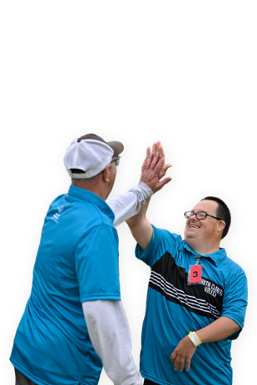

Special Olympics Southern California
Fall Games Championship
November 14–15, 2026, at Fountain Valley Sports Park

TO VOLUNTEER
https://sosclosangeles.galaxydigital.com/need/index?need_id=1308227&need_init_id=16609


